***CONNECTING VISUAL STUDIO.NET WITH MYSQL (ODBC CONNECTIVITY)***

Step 1) Download MYS connector ODBC 64 bit

Step 2) Download MySql.Data.dll file

Step3) Install the connector

Step 4) Create the Database of your Project in mySQL command Line client

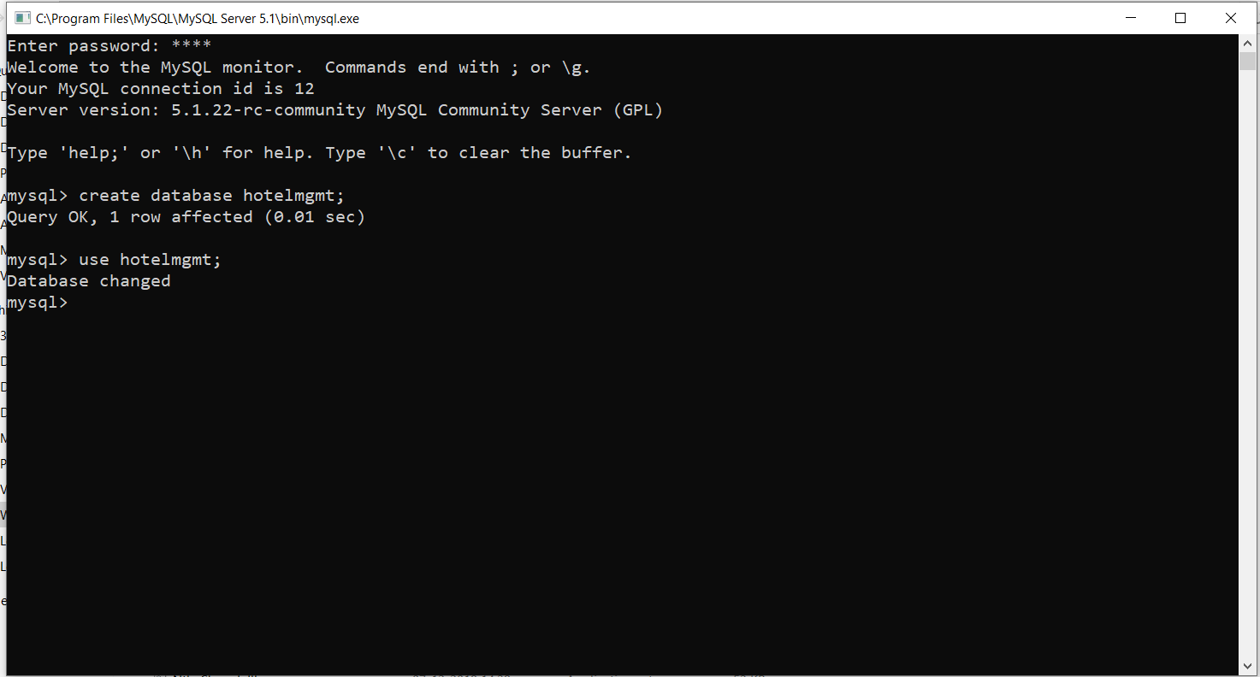

Step 4) Go to This PC/My Computer 🡪 C:\Windows\SysWOW64 🡪 and double click on odbcad32.exe file

Step 5) Follow the steps and create the datasource name

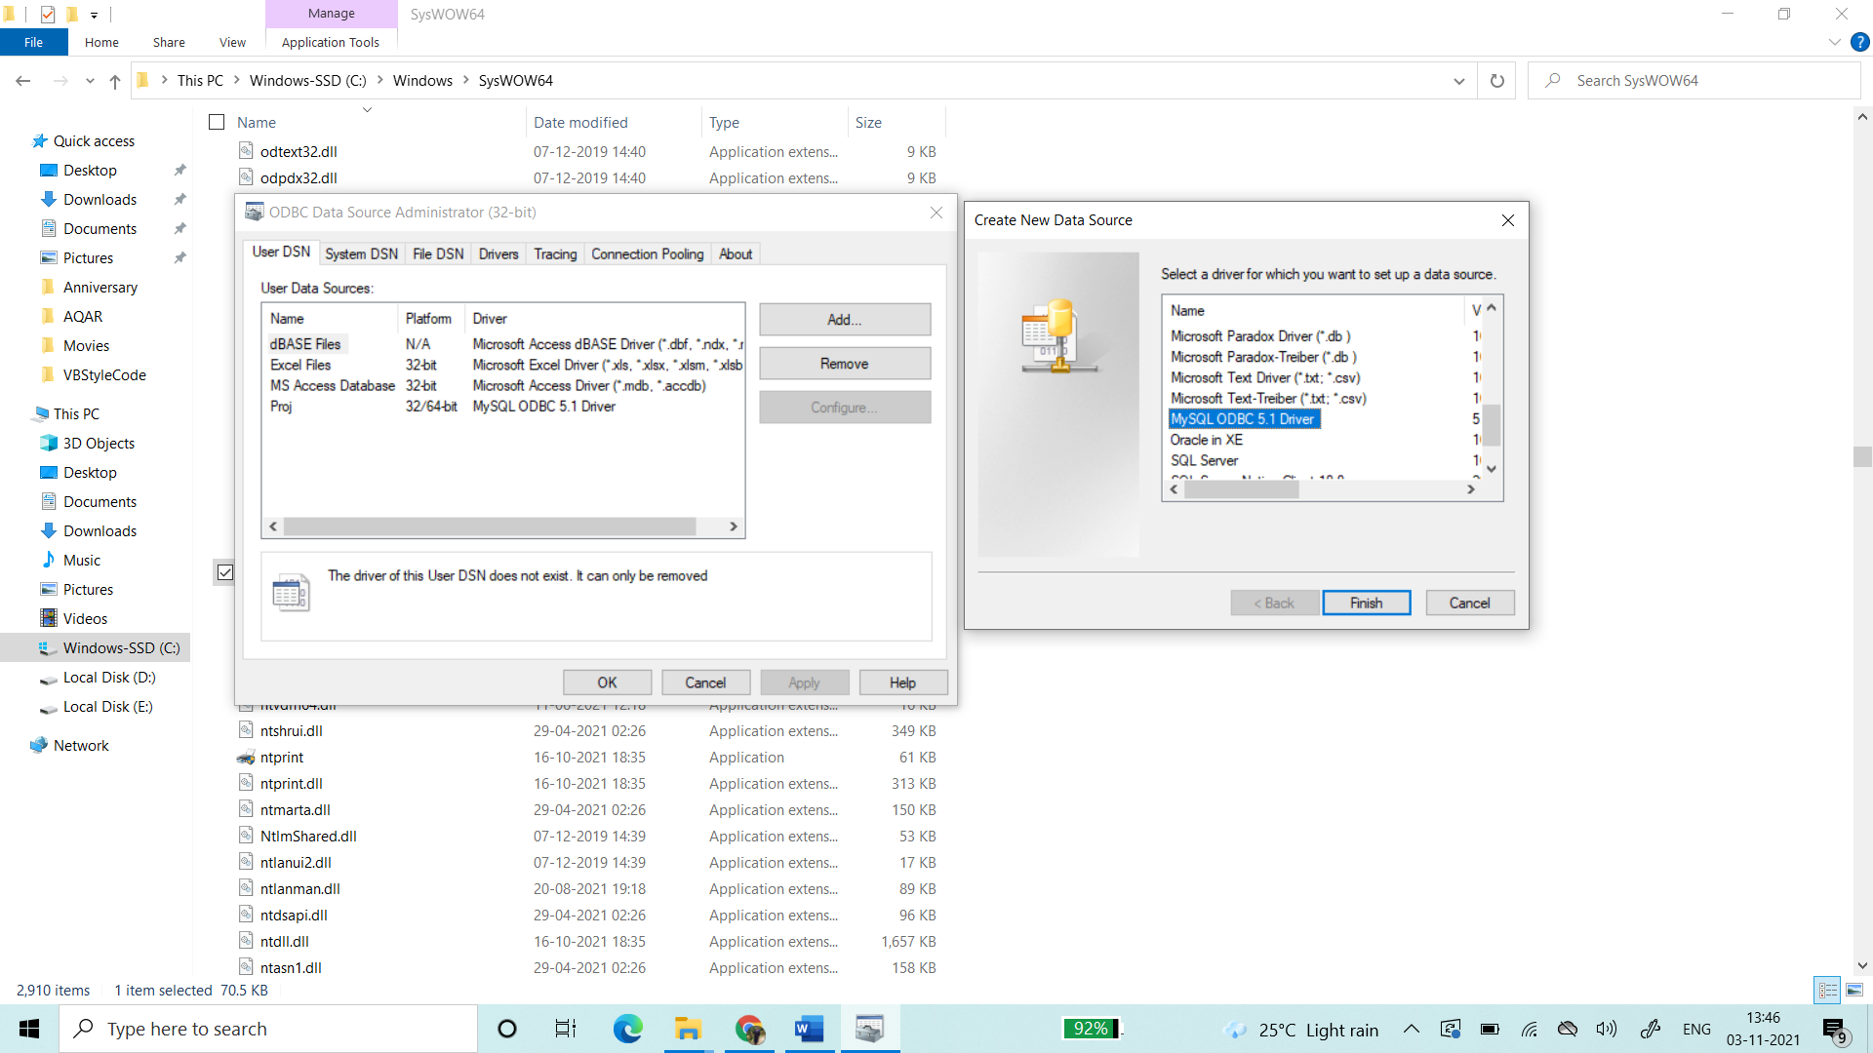

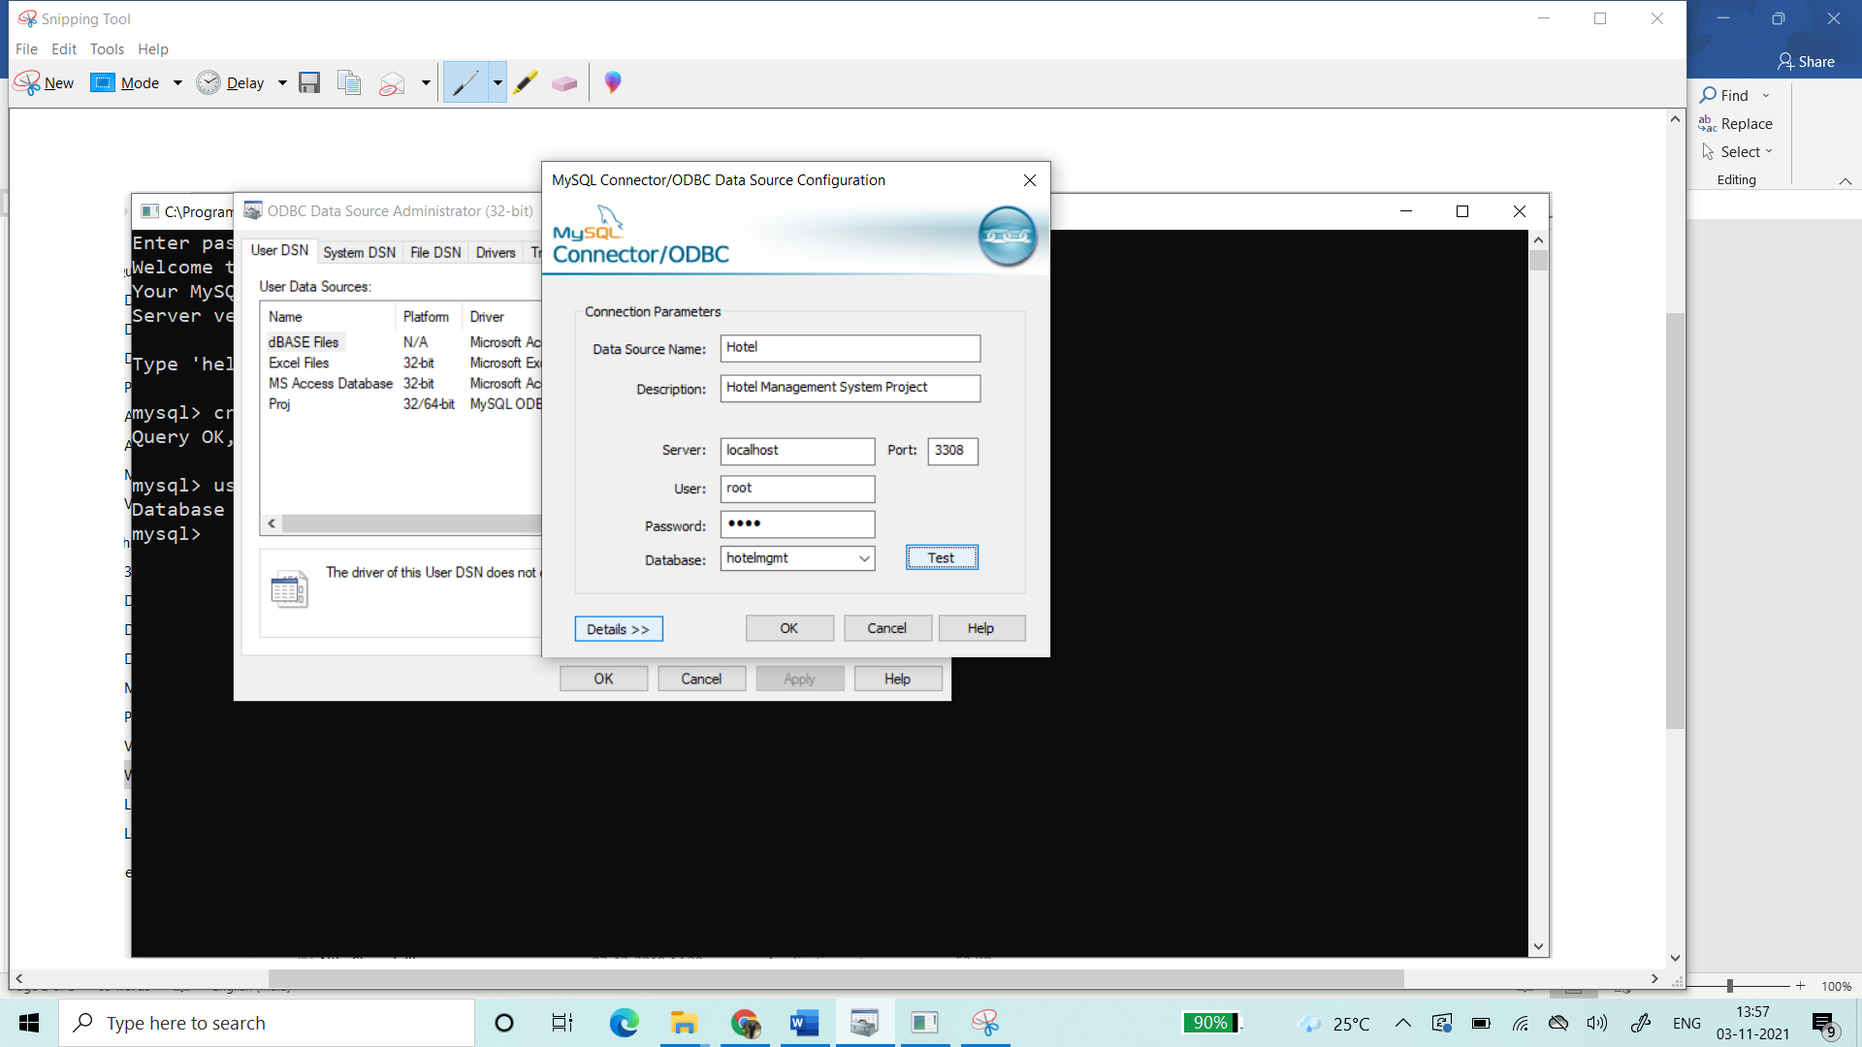

Click on **TEST** button and check the connection

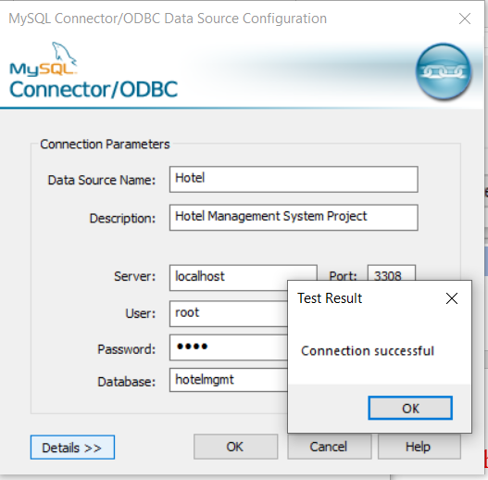

**OPEN VISUAL STUDIO 2015 and SET THE ENVIRONMENT**

1. Open VS 2015 and click on new project.

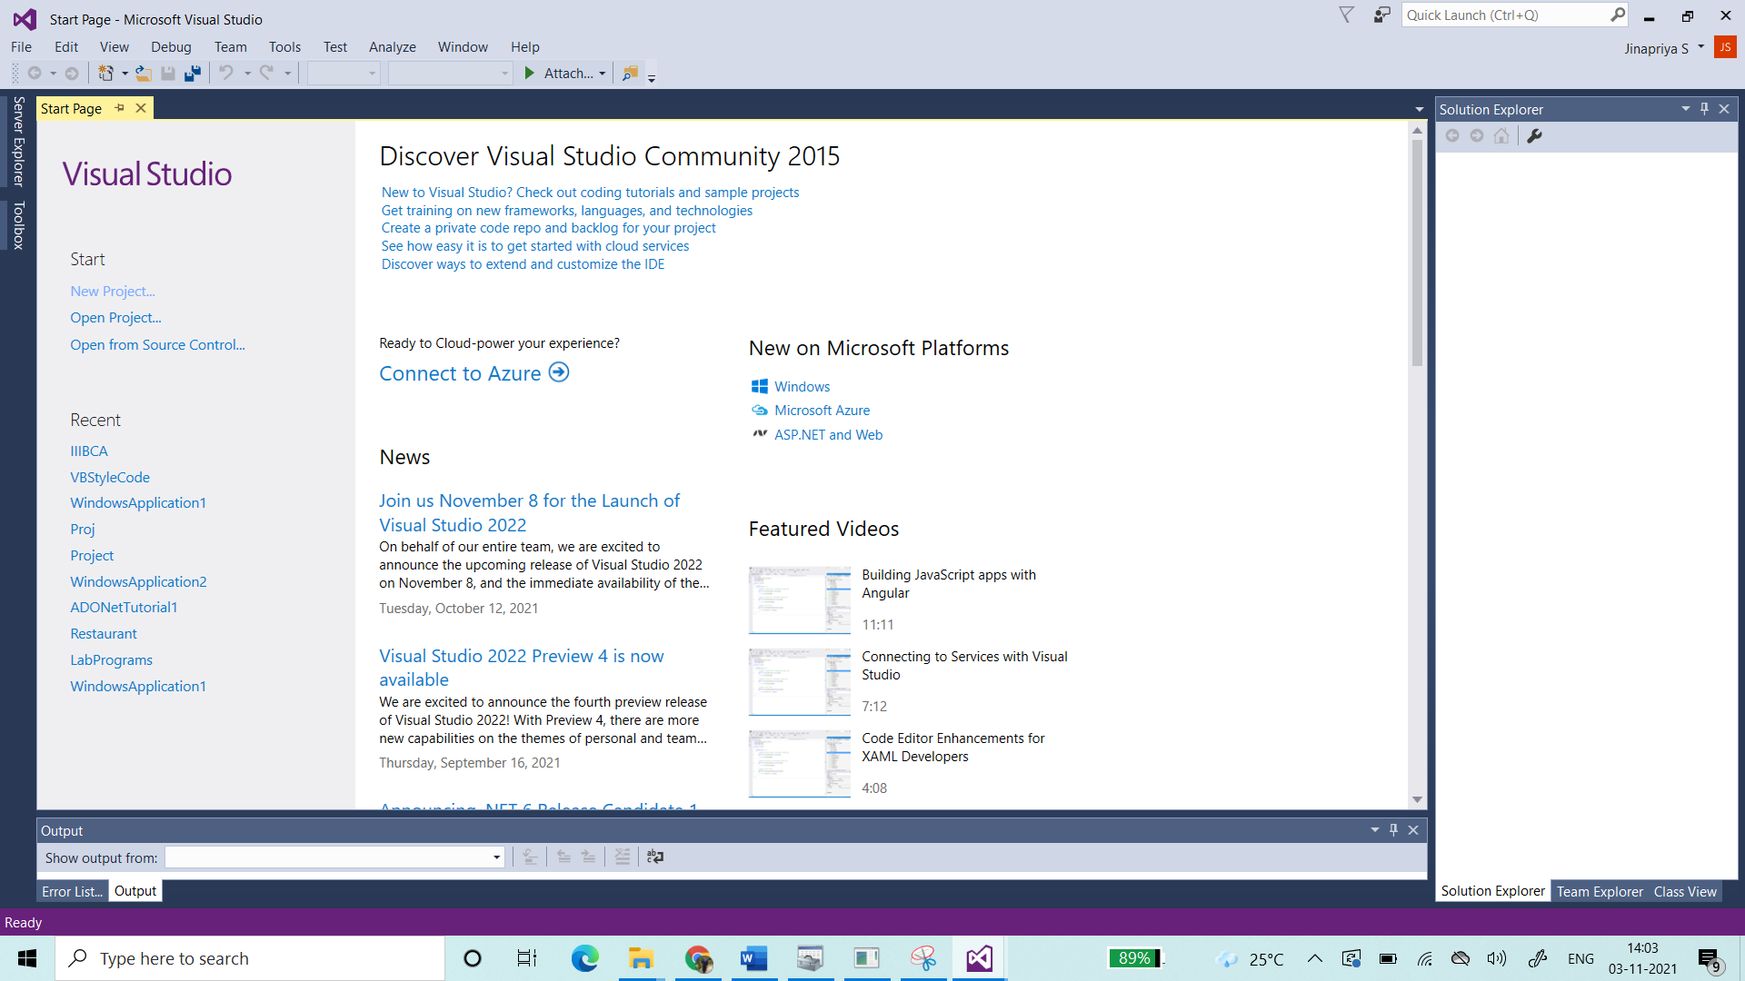

1. Give your Appropriate Project name

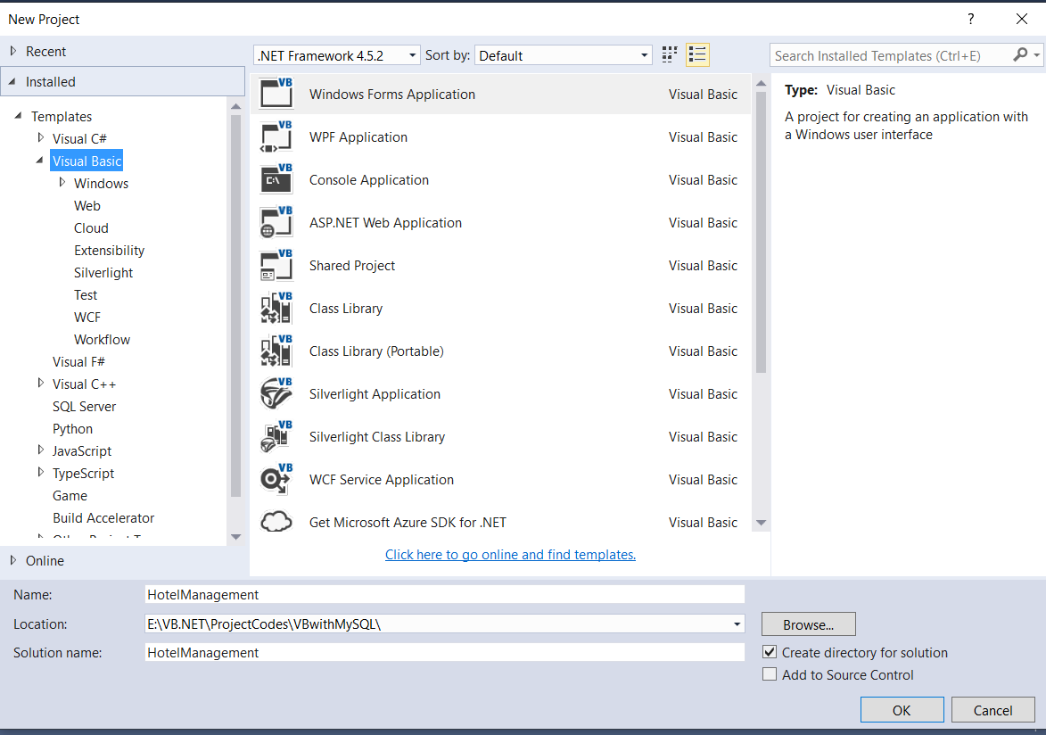

1. On the Project Explorer … Right Click 🡪Add 🡪 References
2. In the Extensions Tab 🡪 click on ADODB
3. In the browse menu select the Mysql.data.dll file and click on OK

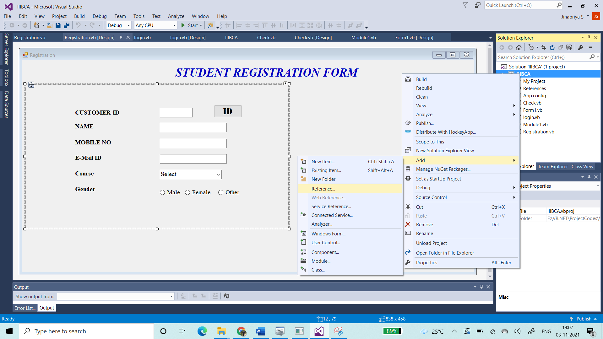

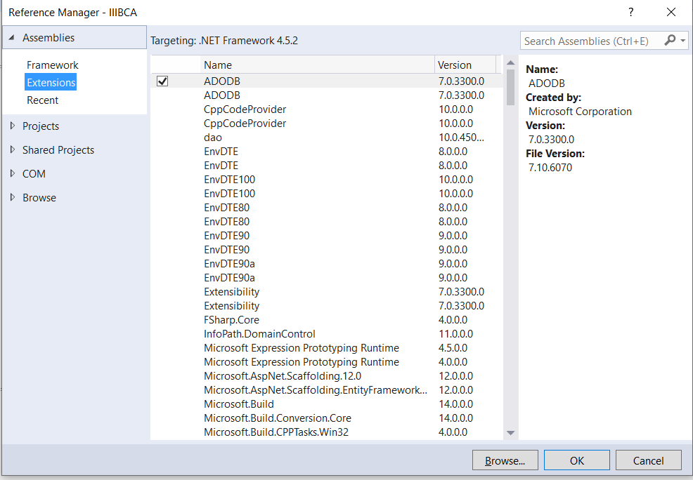

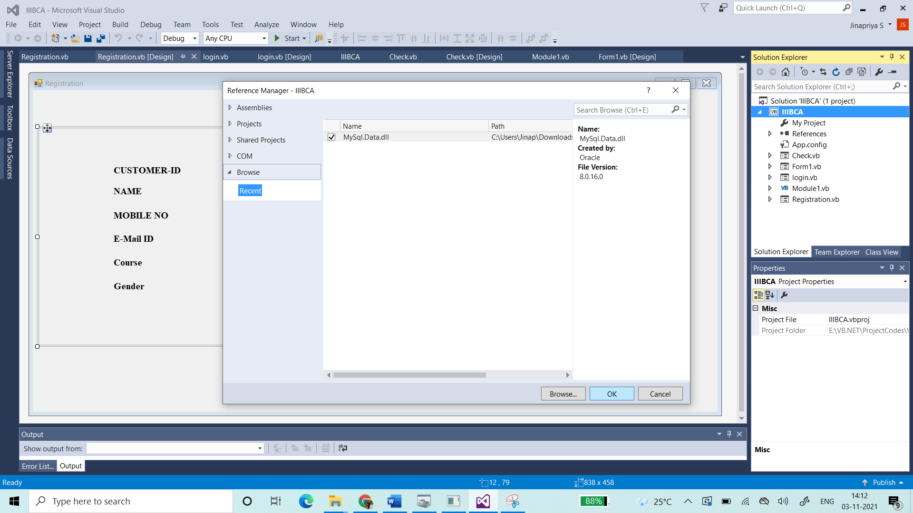

**TO SET UP THE CONNECTION IN SERVER EXPLORER**

1. In the Server explorer 🡪 Right click on Data Connections 🡪 Click on Add Connection

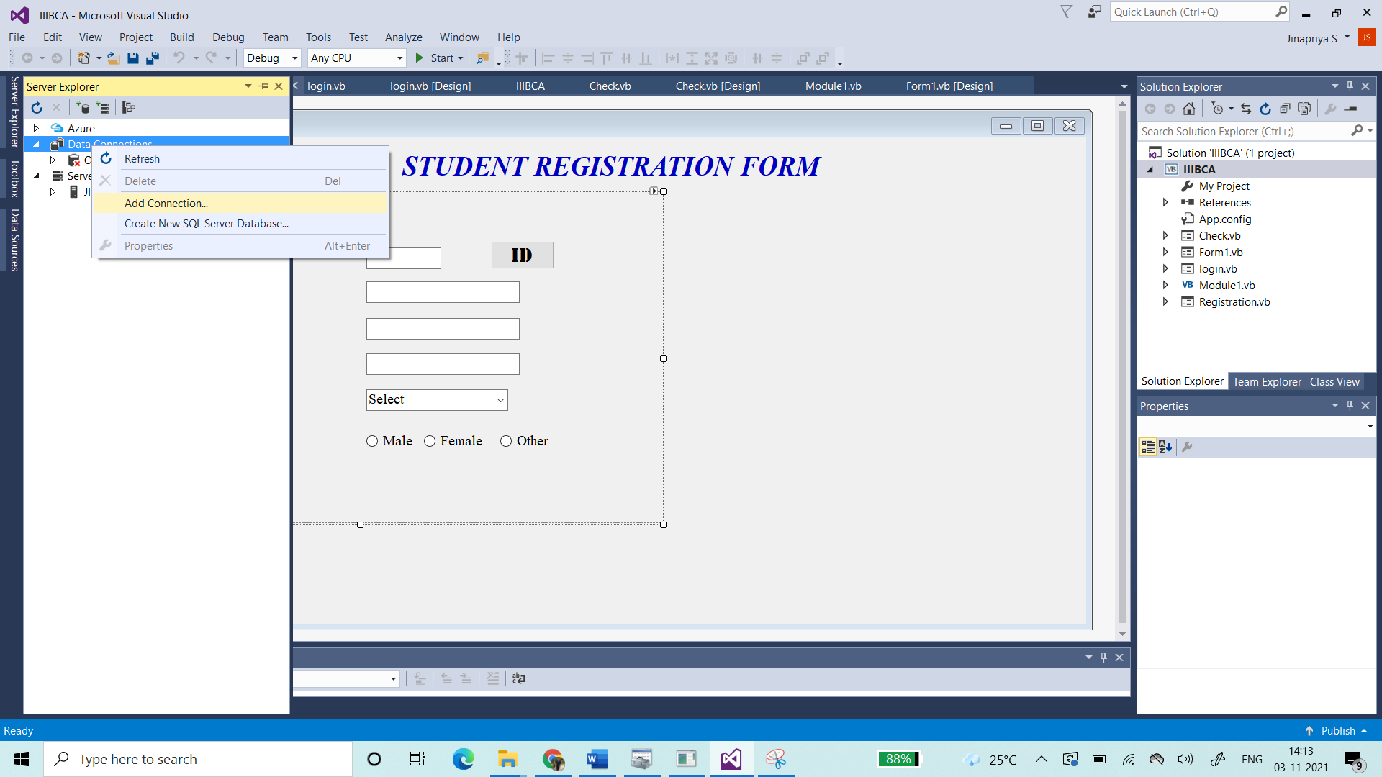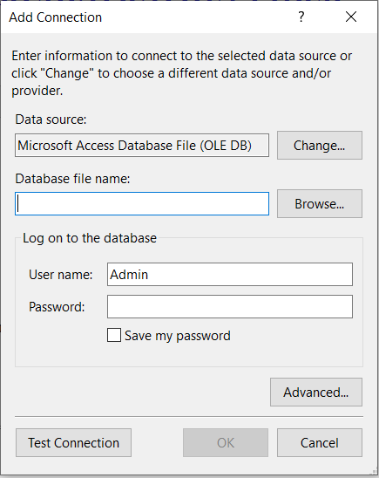

1. Select the DataSource by clicking on the change button

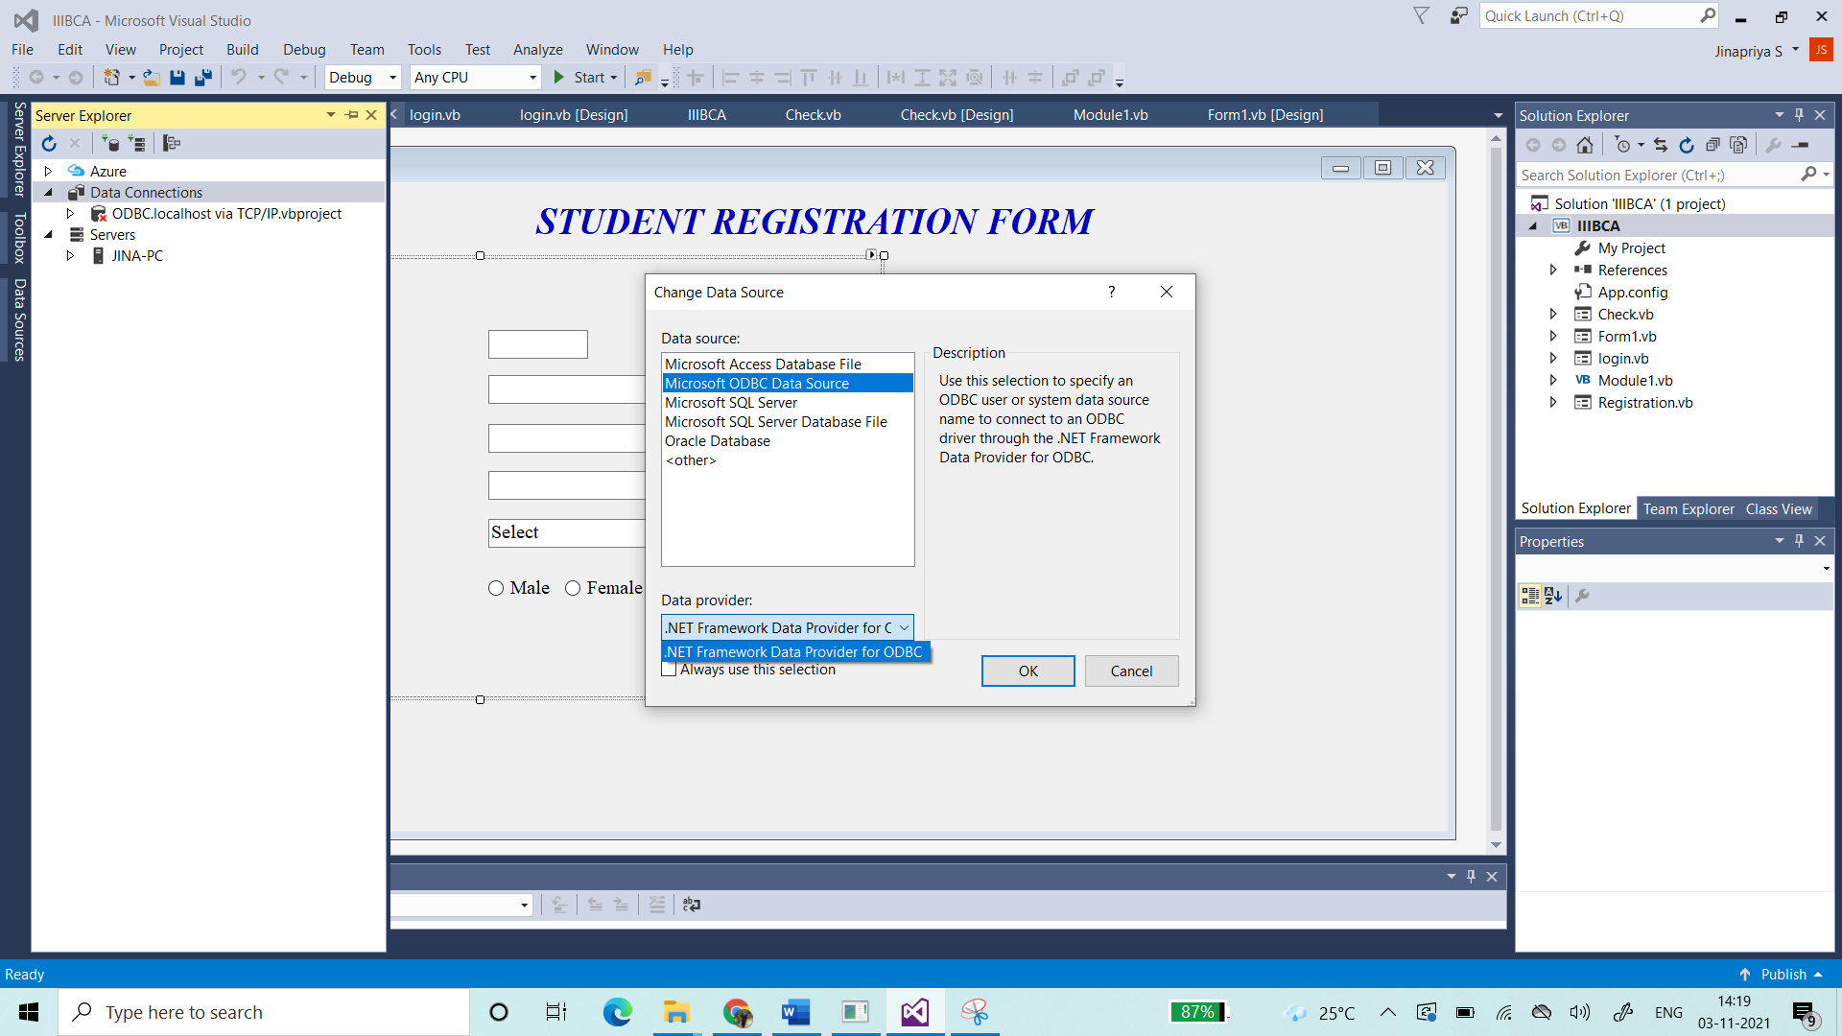

1. Select the Datasource name. Give the login of mySQL

